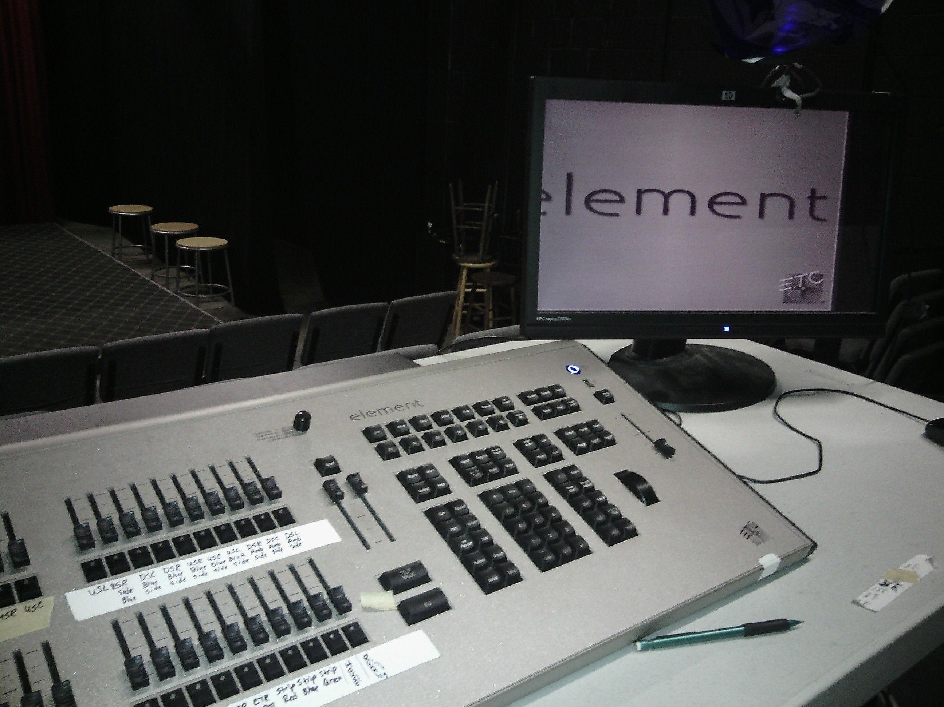
Closing Procedure
- Turn off light board.
(Browser “Power off Device” “Ok” “Shutdown”)
- 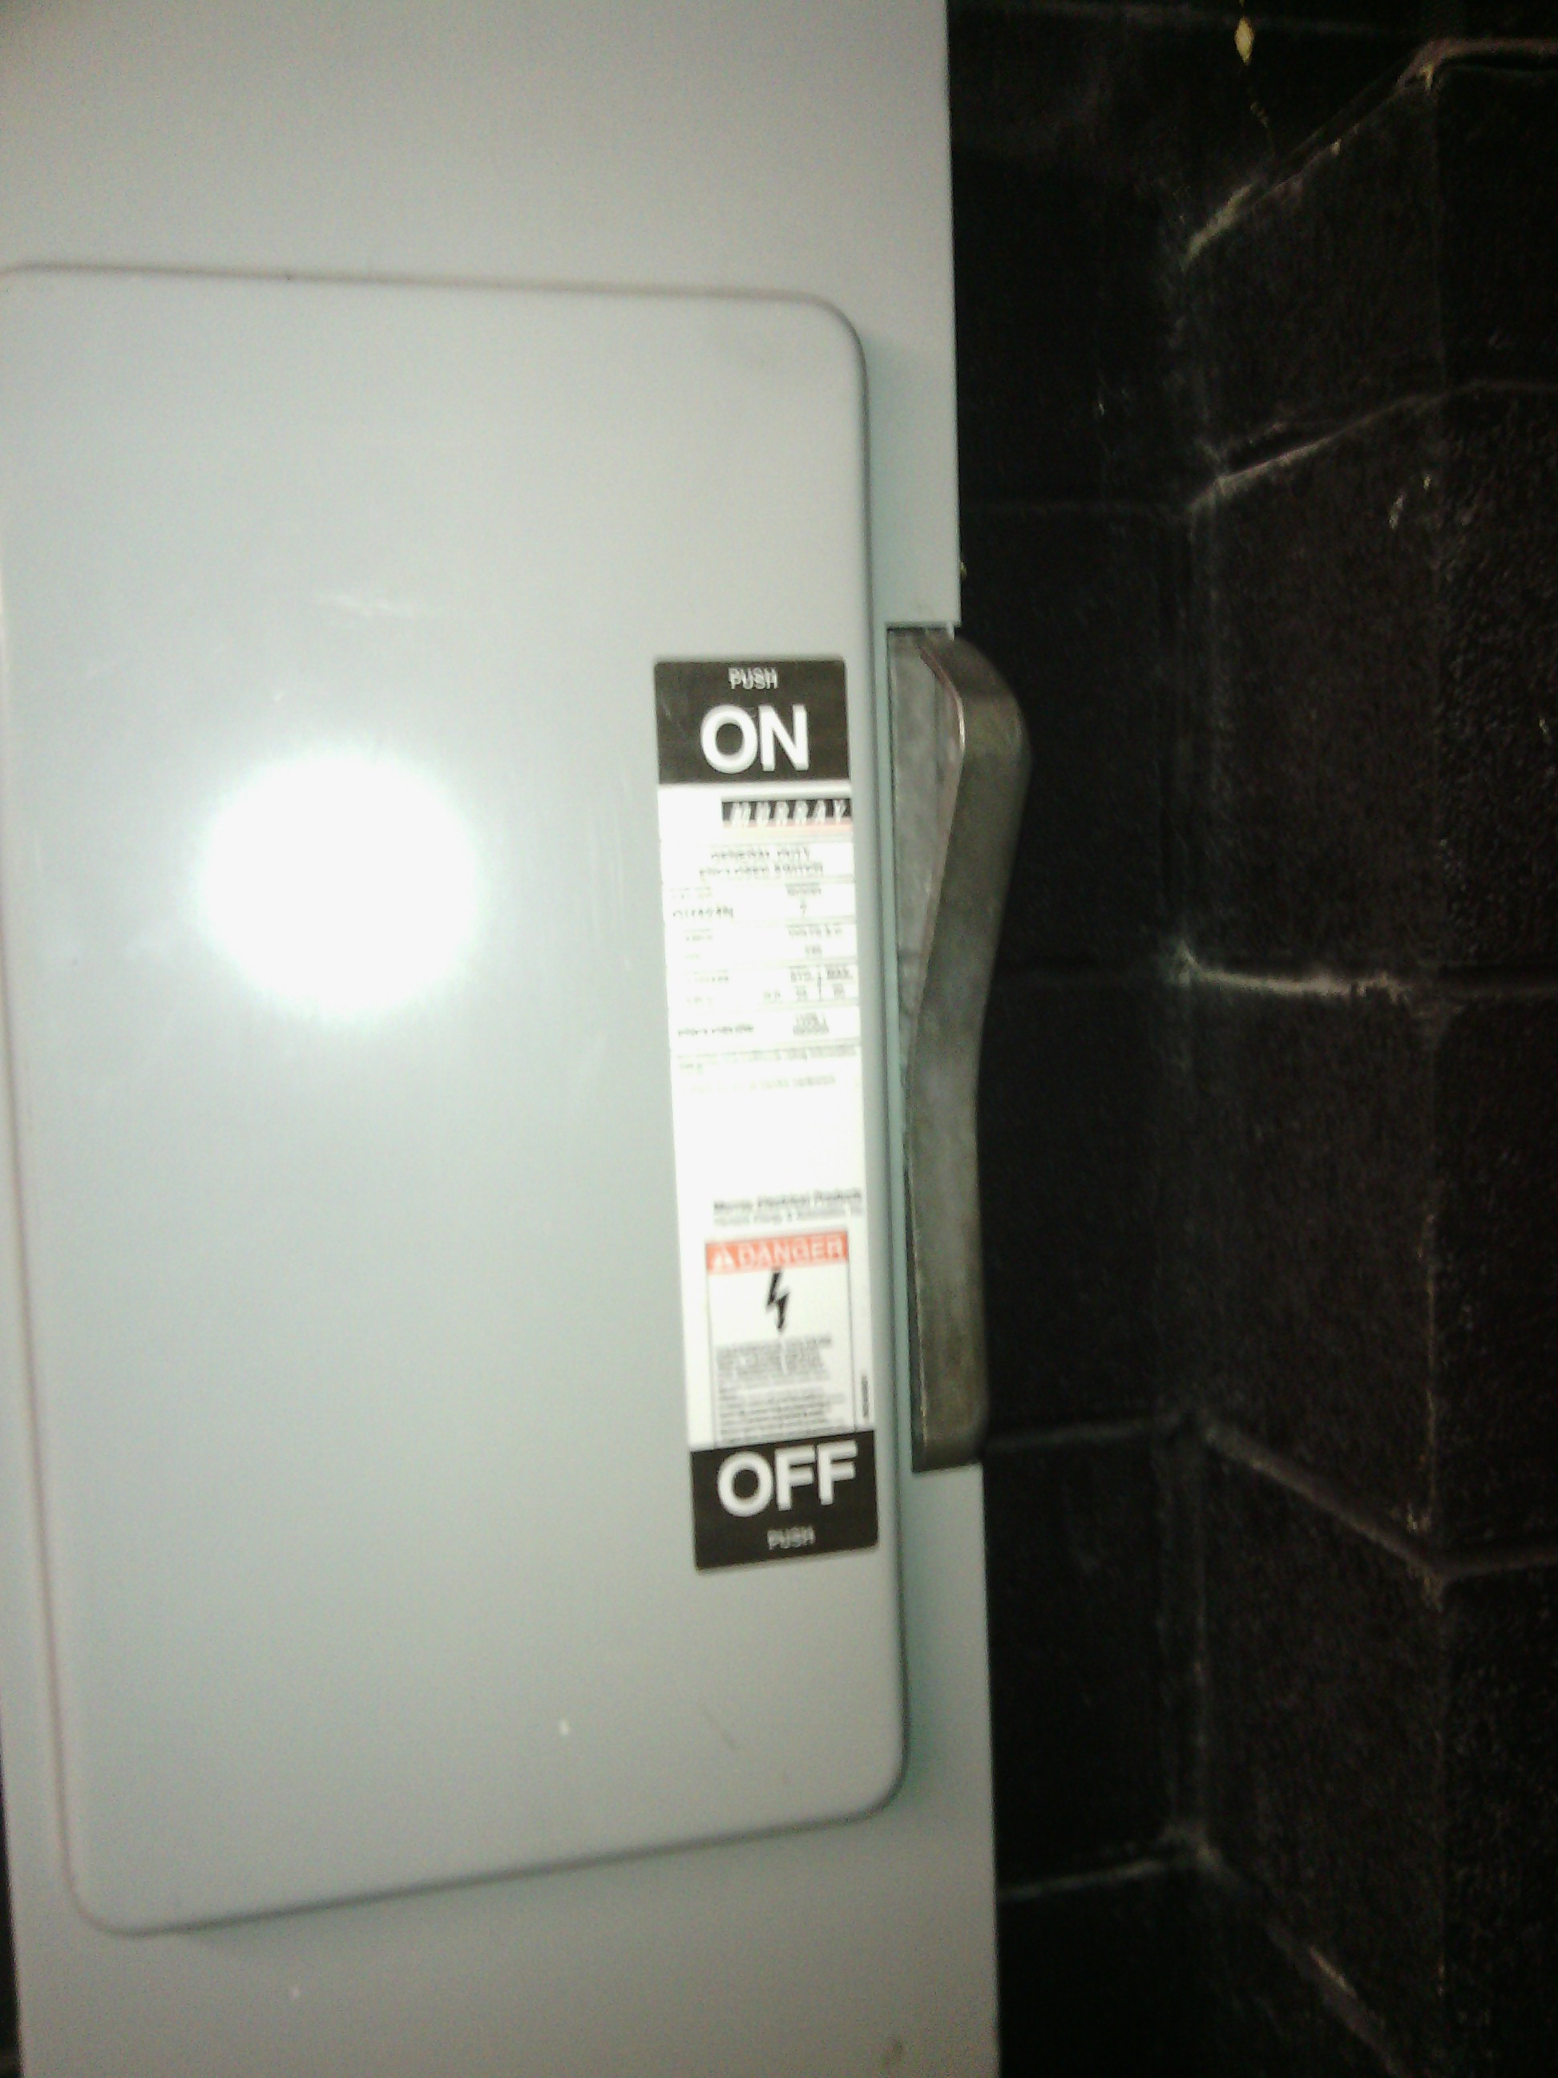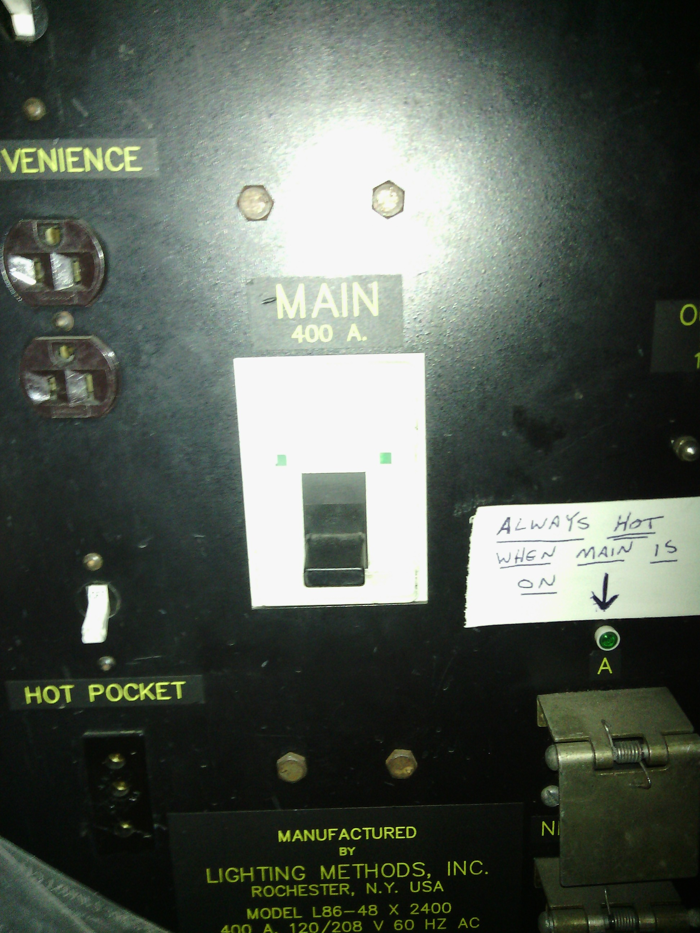Go upstairs through backdoor of Theatre 2. (Bring a flashlight)
1
- Turn off dimmers (Labeled “Main”)
- Turn off breaker (Giant silver switch on wall)
4
3
- 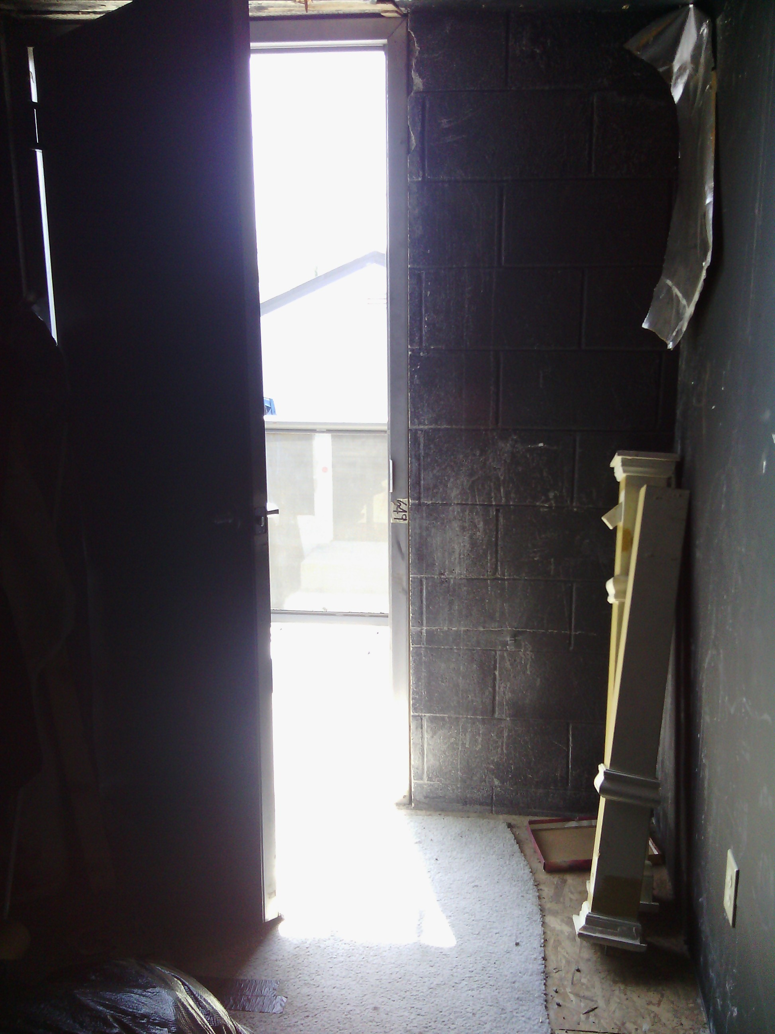Turn off upstairs lights (Switch next to doors to upstairs green room)
- Find your way to door to leave. Make sure that it is locked behind you. (At night it will be more difficult than the photo indicates.)
6
- 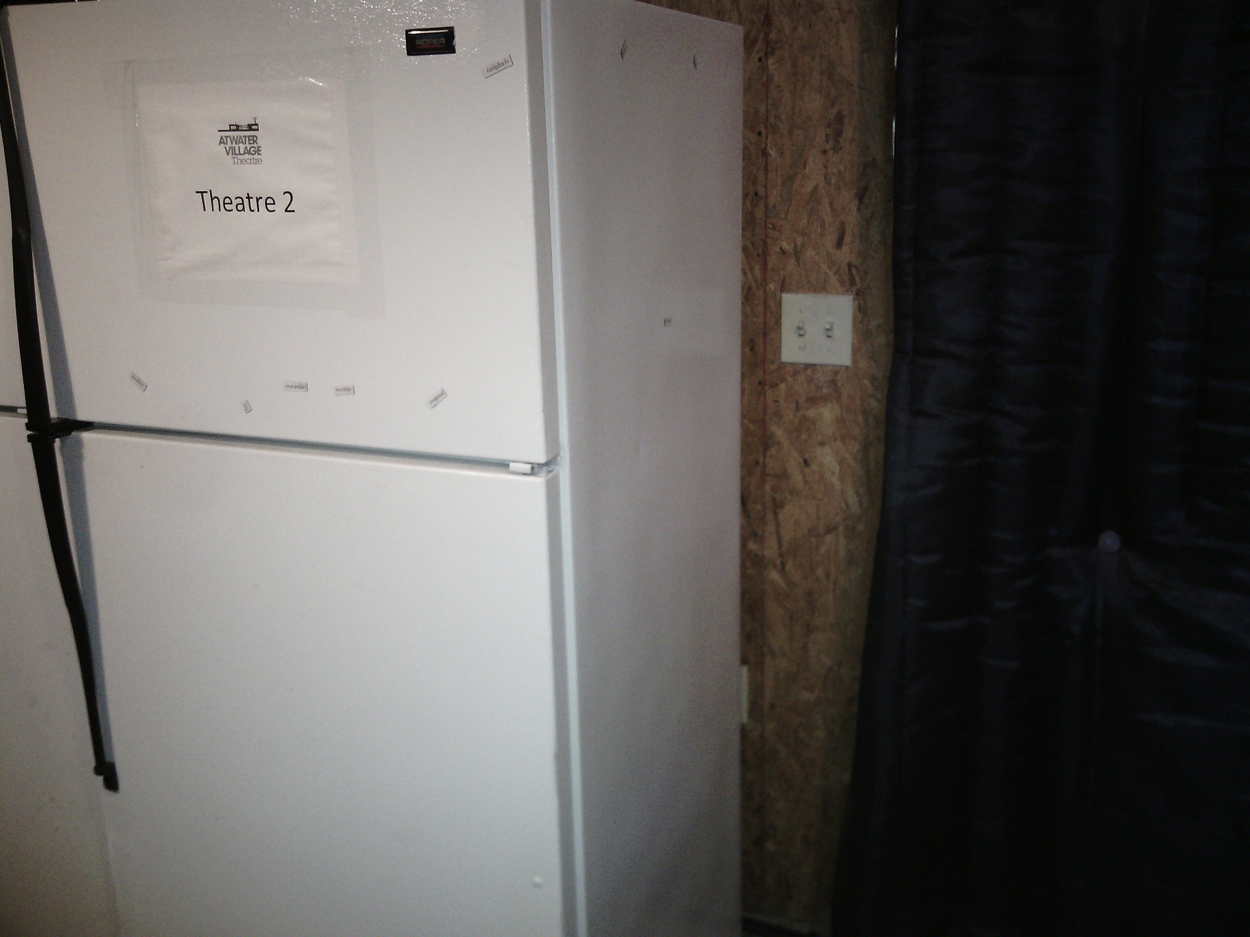Return through backdoor of Theatre 2. Also make sure that it is locked behind you.
- Close elephant and both doors. Make sure they doors are locked.
9
- 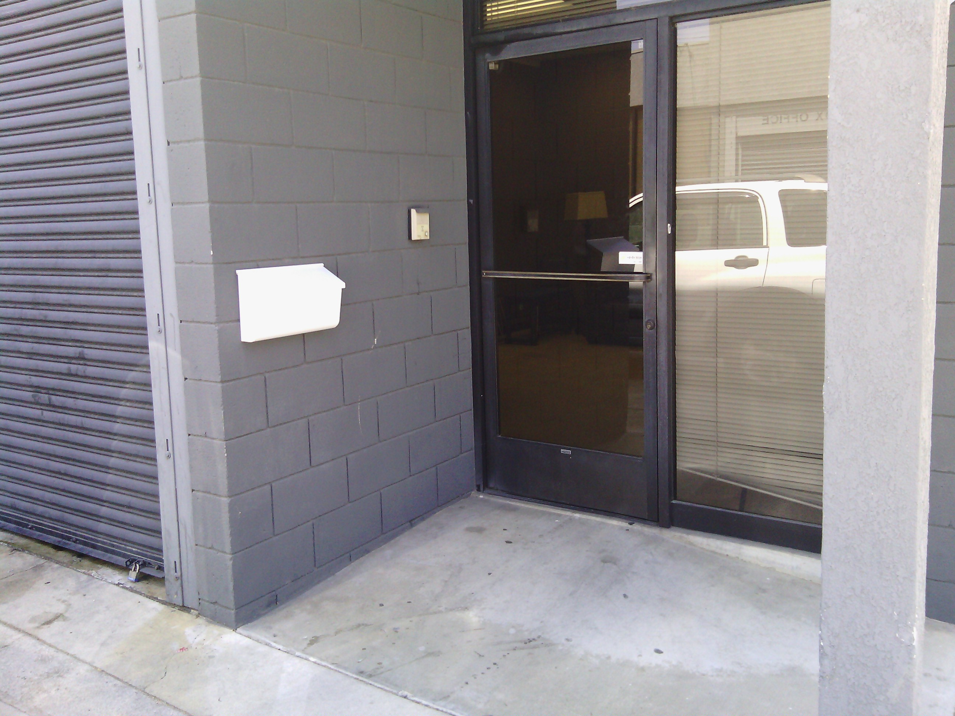Turn off Theatre 2 lights (and exterior, lobby or any other lights.)
- Exit the building. Lock door front door.
10

